LabVIEW Panel: Enum Controls
Preparation
1. Install LabVIEW 2012 or a later version.(For LV test iteration install LV version under test).
2. The media files are located at http://teststand.ni.com/testcases/Adapters/LabVIEW/Media/EnumControls
3. Make all the files writeable and mass compile them with the installed version of LV
4. Set the LV adapter to use the LabVIEW Development System
Validation
Displaying Enumerations
- Open EnumControls.seq in the Sequence Editor
- Verify that the default value shown in the LabVIEW module panel for each parameter is the same value as the value shown in the corresponding control in the VI
- Verify that all the string values defined in the enum control appear in the combo box for that control in the LabVIEW Module panel. (To open the dialog for Enum values, right click on the ring control in the VI and select Edit Items…)
- Verify that the value cannot be changed while the checkbox is checked under the Default column (try selecting a different enumerator in the combo box or typing into the combo box)
- Uncheck the checkbox under the Default column in the LabVIEW Module panel. Verify that the value in the Value column does not change
- Enable hidden properties in TestStand, to do so,
- Select Configure->Station Options…
- In the Station Options dialog, select the Preferences tab and check the option Show Hidden Properties
- Click OK on the dialog
- In the Variables View control under Step.TS.SData.ViCall.Parms, expand to each parameter so you can see the properties ArgVal and ArgDisplayVal. Verify that Numeric value is reflected in ArgVal property and string value in ArgDisplayVal property
- Verify that selecting a new value by entering a numeric value in the Value column that matches one of the enum control numeric values displays the corresponding string value
- Right-click on the step and select Run Selected Steps from the context menu and verify that the controls in the VI show the same values specified in the parameters in the step
- Reload the VI prototype by clicking on the Reload VI Prototype button in the LabVIEW panel.
- Verify that the values under the Value column do not change
- Select the step Top-Level Enum Control Type Defs and specify for its module the VI “TypeDefEnumControls.vi”
Setting the Value to Valid Numbers
- Select the step Setting the Value to Valid Numbers.
- Verify the value for each parameter is valid.
- Verify there are no errors for that step.
- Verify the step executes without throwing an exception.
Setting the Value to Invalid Numbers
- Select the step Setting the Value to Invalid Numbers.
- Verify that each the value of each parameter is displayed in red and has a tool tip stating that the enums must match exactly.
- Verify the analyzer shows an error.
- Verify running the step throws an exception.
Setting the Value to Valid Strings
- Select the step Setting the Value to Valid Strings.
- Verify the value for each parameter is valid.
- Verify the analyzer shows no errors for that step.
- Verify the step executes without throwing an exception.
Enums with quotes
- Open sequence DifferentTypes from //TestStand/WebPages/TestCases/LabVIEWModulePanel/Media/LVModulePanel.seq
- Now, select the step “Enums With Quotest”.
- Verify that you can select each enum.
- Enums that contain quotes are escaped. So, when typing an enum, you need to escape any quotes. Verify that after entering "E\" F\" G" as the expression for the enum parameter the step runs successfully.
- Verify that the step runs successfully after entering expressions like the following: Locals.Foo == "\”A" ? 0: 1. Also, verify that the expression is what you see as the argument for the enum. This is both the display value and the actual value.
Tab Controls Test
Refer : //TestStand/Tests/LV Shared/LV Adapter Tests_New/Enums/SupportFiles/Tab Controls/Tab Control.seq
- Open the sequence specified above.
- Click on each of the step and check for the value for Tab Control Parameter.
- The parameter values should be “Page1” or “Page2” and not the numeric equivalent i.e. 0 or 1
Errors test
Refer : //TestStand/Tests/LV Shared/LV Adapter Tests_New/Enums/SupportFiles/Error Testing.seq
- Open the sequence specified above.
- Click on step “Test Different values in LV and TS error” and hover over variable locals.RetRingVal in the step settings pane ( This variable will be red.)
- Verify that the error tool tip mentions about the numeric values not being same in TS and LV as shown below.
- Click on step “Test Incompatible values in LV and TS error” and hover over variable Locals.RingQuadVal in the step settings pane ( This variable will be red.)
- Verify that the error tool tip mentions about the compatibility between TS and LV as shown below.
- Click on step “Test error for NEW values in LV” and hover over variable Locals.TextRing3 in the step settings pane (This variable will be red.)
- Verify that the error tool tip mentions about the difference in enumerators between TS and LV as shown below.
- Click on step “Test error for change in string values in TS” and hover over variable Locals.TextRing3 in the step settings pane (This variable will be red.)
- Verify that the error tool tip mentions about the difference in enumerators between TS and LV as shown below.
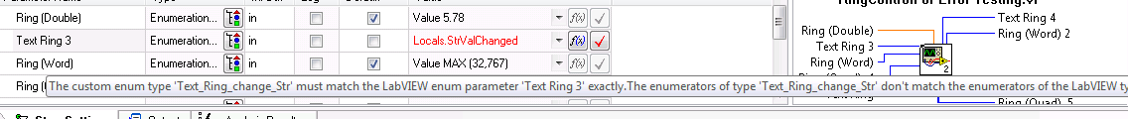
- Click on step “Enum controls with TS enumerators string changed” in the “EnumSequence” and hover over variable Locals.SeasonsStErr the step settings pane (This variable will be red.)
- Verify that the error tool tip mentions about the difference in enumerators between TS and LV as shown below.
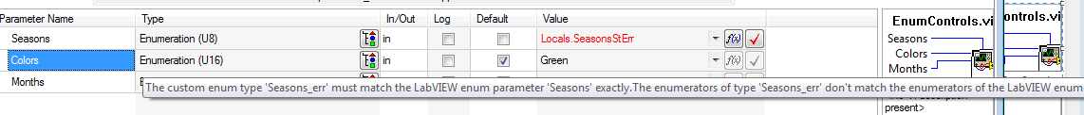

- Click on step “Enum controls with TS enumerators value changed” in the “EnumSequence” and hover over variable Locals. SeasonsValErr the step settings pane (This variable will be red.)
- Verify that the error tool tip mentions about the difference in enumerators values between TS and LV as shown below.
- Click on step “Check for duplicate values” in the “MainSequence” .Try to create the enum using the icon.Verify that the enums are not created and warning is given about duplicate enumerator values .
Click on step “Error with ring control with TS flag enum for double” in the “MainSequence” .Hover on the locals.flagenum.Verify that you see an warning about Flag enum not supported for Rings doubles,single and extended. .

Ring and enums under cluster and arrays
- Add a new action LV step type
- Select the vi (TestStand\WebPages\TestCases\Adapters\LabVIEW\Media\EnumControls\RingArray and Ring.vi)
- Expand Array 9 node and check that the ring value is shown as drop box as below (not shown as numbers or as unknown)
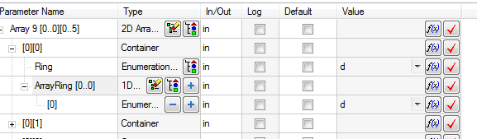
- Expand cluster 3 node and check that the array ring are shown as drop box as shown below ( not shown as numbers or unknown)
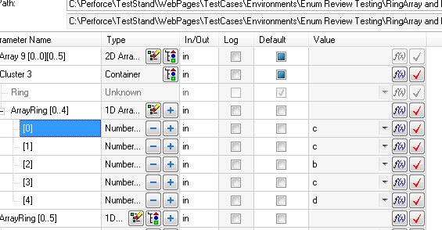
- Expand ArrayRing node and check that the enums are shown in drop box as below ( not shown as numbers or unknown)
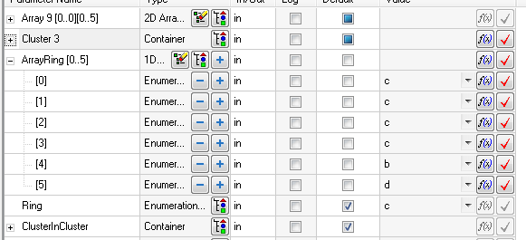
- Expand Cluster in cluster node and check that the enums are shown in drop box as below ( not shown as numbers or shown as unknown)
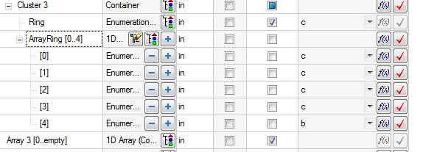

- Add an action vi step call “\TestStand\WebPages\TestCases\Adapters\LabVIEW\Media\EnumControls\RingValues.vi”. Ensure that the value is shown in drop down as shown below.
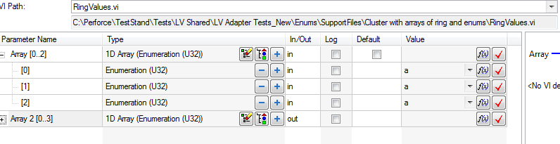
- Test different combination of ring and enums (arrays and cluster combinations).Refer “TestStand\WebPages\TestCases\Adapters\LabVIEW\Media\EnumControls\EnumArray and Enum.vi”. For the below steps expand and verify that drop boxes are shown for enums / rings.Also run the steps and debug in and out of the vi. Verify the values when you debug in and out of the LV.

  - Expand Array and verify that the enums are shown in drop box and not as numbers or unknown.
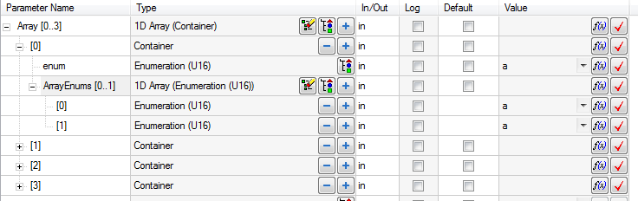
  - Expand ArrayEnums
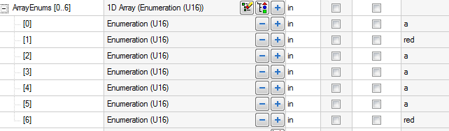
  - Expand Array 11 and verify the enum is shown in drop box as shown below.
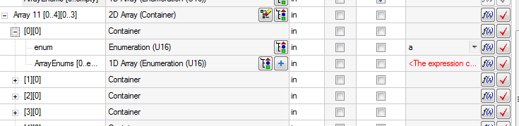
  - Expand clusterincluster and check enum is shown in drop box.
